Lab 6
- List employees with their department name & location
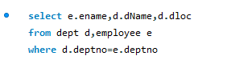

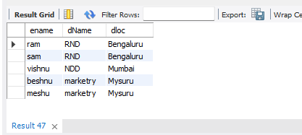

2)Employees who are not assigned to any project ,Project-wise headcount
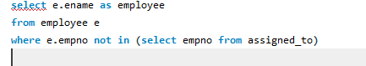
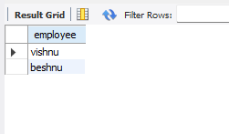

3) Department-wise average & max salary
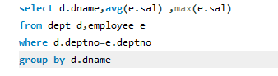
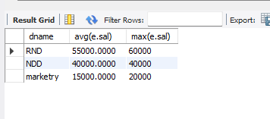
4)Total incentives earned by each employee (lifetime)
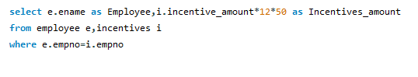
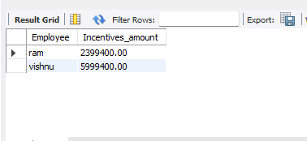
5)Employees working on a given project (project name :Alpha Project)
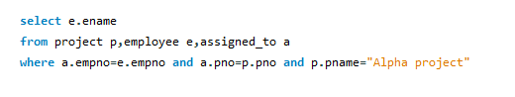
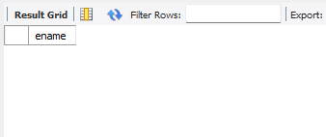

6)Departments with no employees
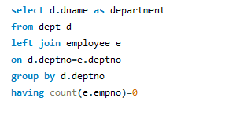
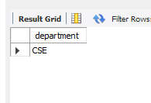

- Employees assigned to more than one project.
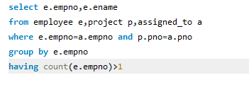

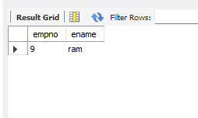

- Managers and their direct report counts (MGR_NO references EMPNO)

